# 

**Dharmsinh Desai University, Nadiad**

**Faculty of Technology**

**Department of Computer Engineering**

# Tech. CE Semester – VI

# Subject: System Design Practice

# Project title: Attendance Management System,

#### By:

#### Katrodiya Chirag, roll no: CE059, Id: 17CEUOS106

#### 2) Kathiriya Ronak, roll no: CE057, Id: 17CEUOG069

**Guided by:** **Prof. Jigar M. Pandya**

* 1. **DHARMSINH DESAI UNIVERSITY**
  2. **NADIAD-387001, GUJARAT**



* 1. **CERTIFICATE**
     1. This is to certify that the project entitled as “**Attendance Management System**” is a bonafide report of the work carried out by

1) **Mr. Katrodiya Chirag,** Student ID No: **17CEUOS106**

2) **Mr. Kathiriya Ronak,** Student ID No: **17CEUOG069**

of Department of Computer Engineering, semester VI, under the guidance and supervision of **Prof.** **Jigar M. Pandya** for the subject System Design Practice. Here is the Report of Academic Project for the Subject.

|  |  |
| --- | --- |
| Project Guide | Head of the Department |
| Prof. Jigar M. Pandya | Prof. C.K Bhensdadia |
| Department of Computer | Department of Computer |
| Engineering, | Engineering, |
| Faculty of Technology, | Faculty of Technology, |
| Dharmsinh Desai University, | Dharmsinh Desai University, |
| Nadiad | Nadiad |
| Date: 25/04/2020 | Date: 25/04/2020 |

# Contents:

1. Abstract 4

2.Introduction 5

3.Software Requirement Specifications 6

4.Design

1) Use Case diagram 10

II) Class diagram 11

III) Sequence diagram 12

IV) Activity diagram 13

V) Data Flow diagram 14

5.Implementation Detail 16

6.Testing 18

7.Screen-Shots 19

8.Conclusion 24

9.Limitation and Future extension 25

10.Bibliography 26

# Abstract

Attendance this word is used in many places. In School, Colleges, Institute, Big Companies, Seminars etc. In school & colleges student’s & faculty’s attendance is taken. Where in companies & organization all employee’s attendance is taken.

Depending on attendance of employee the salary will be decide by organization. Student will get relatively marks from their attendance in the class. So the management of the attendance is very important nowadays. It should be well recorded & whenever need any repot one that like month wise or date wise, it should easily available to employer or teacher who handle attendance in school, colleges.

Nowadays using the technologies, we can build some system which reduces work of admin department who previously manages the attendance in register and make report from it, that was very boring & tedious task. We have built the system in which attendance taker has to scan Qr-code which is on the ID card of students(example), and record will be saved for that particular date.

# Introduction

Attendance Management System in which there are mainly two users Admin and Teachers. This System is specifically for schools in which all class teacher takes attendance of students of their associated classes in first lecture. Basically all students will have their ID card with Qr-code. Qr-code represent identity of that student. Which will be provided by Admin. When any student come in the class, class teacher having this app on his/her phone will scan the Qr-code on the ID card of the student & attendance will be taken for that student for that date.

Teacher have to first login with their id/password given by admin. After login teacher can register student in the app at the first time of use. After that teacher can also edit information of student. As informed in above paragraph teacher will take attendance, after that they can see record of student on particular date, that who was absent & who was present. Teacher have one more functionality in which by pressing one button they can notify the parents whose children are absent Today.

Admin side is built in mvc asp.net so that it can access through pc machine. Admin can add new teacher also update teacher’s information. Admin can list all students registered in the system and can take print out of their ID card whenever needed.

**Technologies/tools used :**

* Platform used: Visual Studio 2019 for Admin side

Technology: MVC Asp.net

* Platform used: Android Studio 2019

Technology: Android (application)

* Platform used: google fire store (Online Database)

# Software Requirement Specifications:

**Attendance Management System**

Admin

R 1.1 Manage Class

Description: Admin manage classes here

R 1.1.1 Add Class

Description: Admin can add classes here

Input: Class name, teacher

Output: Class Id

R 1.1.2 Remove Class

Description: Admin can remove classes here

Input: Class Id

Output: Success message

R 1.1.3 Edit Class

Description: Admin can edit class-teacher here

Input: Class Id, Edit values

Output: Save Changes

R 1.1.4 View Class

Description: Admin can view class detail here

Input: Class Id

Output: Display Details (students, class teacher)

R 1.2 Manage Teacher

Description: Admin manage teachers here

R 1.2.1 Add Teacher

Description: Admin can add teacher here

Input: teacher name, contact, email

Output: Teacher Id

R 1.2.2 Remove Teacher

Description: Admin can add teacher here

Input: Teacher Id

Output: Success message

R 1.2.3 Edit Teacher

Description: Admin can edit teacher's detail here

Input: Teacher Id, Edit values

Output: Save Changes

R 1.2.4 View Teacher

Description: Admin can add teacher here

Input: Teacher Id

Output: Display Details

Teacher

R 2.1 Login

Description: Teacher can login here by provided id, Password

Input: Input Credential

Output: Home page

R 2.2 Manage Student

Description: Teacher manage student here

R 2.2.1 Add Student

Description: Teacher can add student here

Input: student name, standard, Roll no., Parent's Contact no.

Output: Student Id, Qr-code

R 2.2.2 Remove Student

Description: Teacher can add student here

Input: Student Id

Output: Success message

R 2.2.3 Edit Student

Description: Teacher can edit student's detail here

Input: Student Id, Edit values

Output: Save Changes

R 2.2.4 View Student

Description: Teacher can view student's detail here

Input: Student Id

Output: Display Details

R 2.3 Manage attendance

R 2.3.1 Scan Qr-Code

Description: Teacher can scan Qr-code of student for taking attendance

Input: Qr-code

Output: verify student

R 2.3.2 View Record

Description: Teacher can view Record of student

Input: Student's Detail

Output: Display Record

R 2.3.3 Update Attendance

Description: Teacher can Update Attendance of student

Input: Student's Detail, Date

Output: Save Changes

R 2.4 Send Message to Parents

Description: Teacher can send message to parents of absent students

Input: Student Id

Output: Message Sent

# Design:

* Use Case diagram

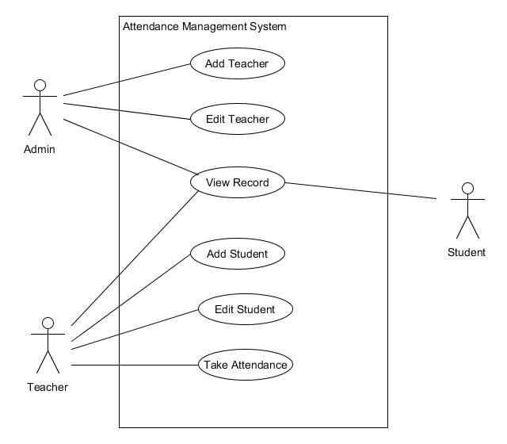

* Class Diagram

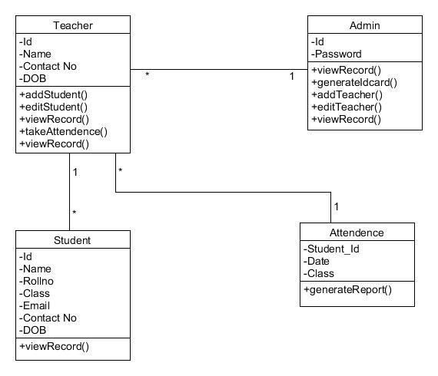

* Sequence Diagram

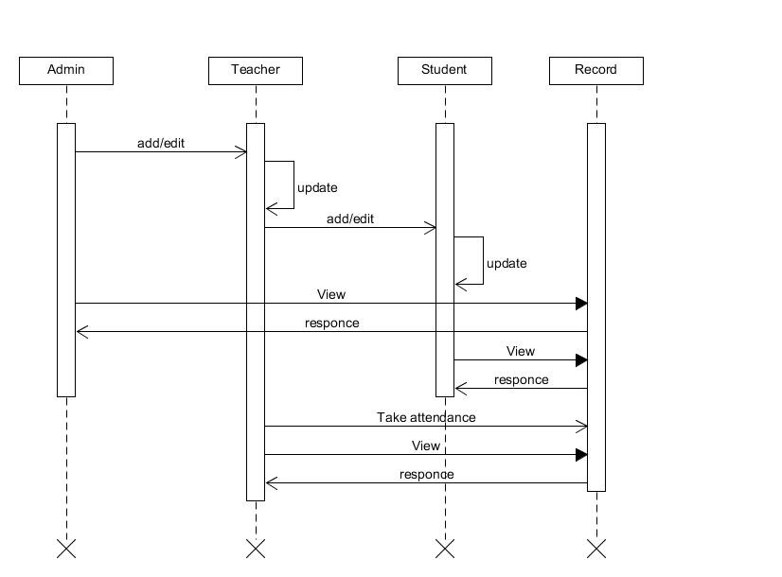

* Activity Diagram

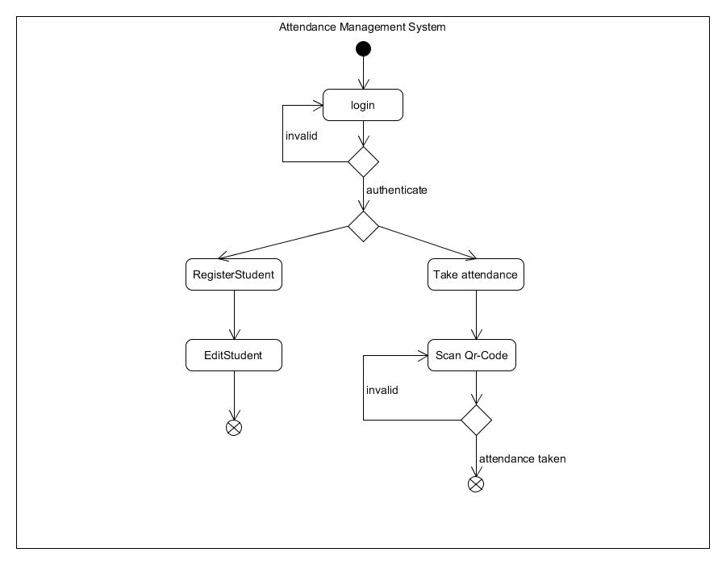

* Data Flow Diagram

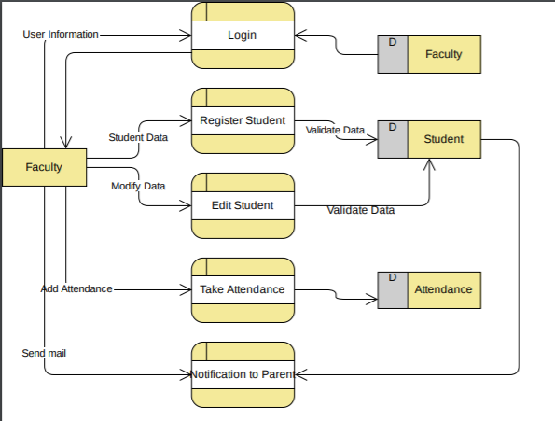

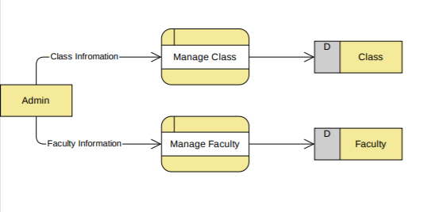

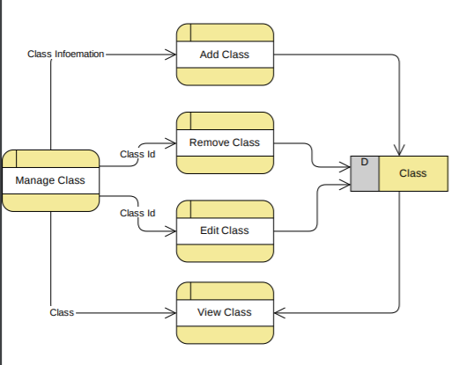

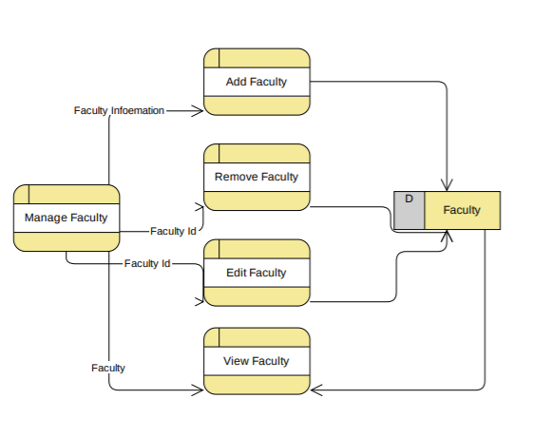

# Implementation Detail:

## Modules:

In following section brief description of each module is given related screen shots are attached in separate section.

Manage Student-module:

In manage student module teacher have access to add student of their class at the first time. If student change class room or any other detail of student is changed then teacher can update it also.

Manage Teacher-module:

Manage teacher module appear in admin side. Admin have all access to add teacher with their associated class. And can perform crud operation on teacher object.

Authentication-module:

Admin & teacher must have to login to the system for using any of the functionality. Detailed description can be seen in screen shot section. In our application we have defined that one’s teacher have login in one device so his/her don’t have to re-login until they log out from application.

Manage Attendance-module:

Manage Attendance is the main module in our system because all main functionality is performed here. Detailed function can be seen in next part which is major functionality, in brief teacher will take attendance here and notify parents whose children were absent for present day. Also teacher can see the report for enter particular date and for particular class that who were present & who were absent that day.

## Major Functions prototypes

#### Add function:

Add function is common in student and teacher module to add teacher and register new students.

#### Update function:

Update function is common in student and teacher module to update teacher/students information.

#### Make All Absent function:

Make all absent method will work for absent all student of given class. This method teacher has to use before taking the attendance. And after taking the attendance whom student is present today their present will be reflect in database. The importance of this method is that this can be done system generated daily but system don’t know which day is holiday so by mistily system put absent on holiday.

#### Take Attendance function:

Teacher will provide class name and press take attendance button so scanning window can be saw. After that teacher has to scan the qrcode of student which will be given by admin after the registration of student. After successfully scanning qr code ID of student can be seen by teacher, they have to press next & can take attendance of next student.

#### View Record function:

If teacher want the record of students, then they have to provide the date and class name so for that class on that day who were present and who were absent can be seen by teacher.

#### Notify parents function:

By using this function teacher provide class name & press notify parents button so for that day of the given class’s absent children’s parent will get message that his/her children is absent today in the school.

## Testing:

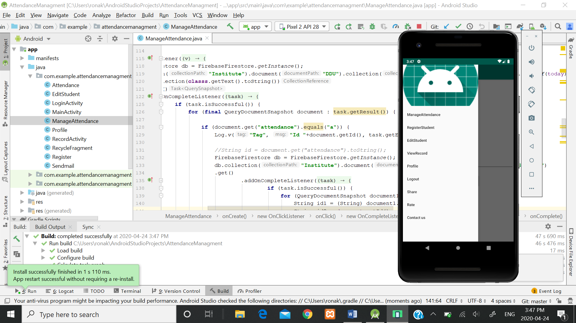

* For testing purpose we have use android emulator so that we can test our application on any android device using this.
* Also we have use USB debugging for check whether app working correctly & debug the component we have created.
* For USB debugging we have to connect the phone via USBcable to android studio.
* At the end of project, we have tested whole system with end-end testing.

# Screen-Shots:

Teacher Login page

Generate Qr code

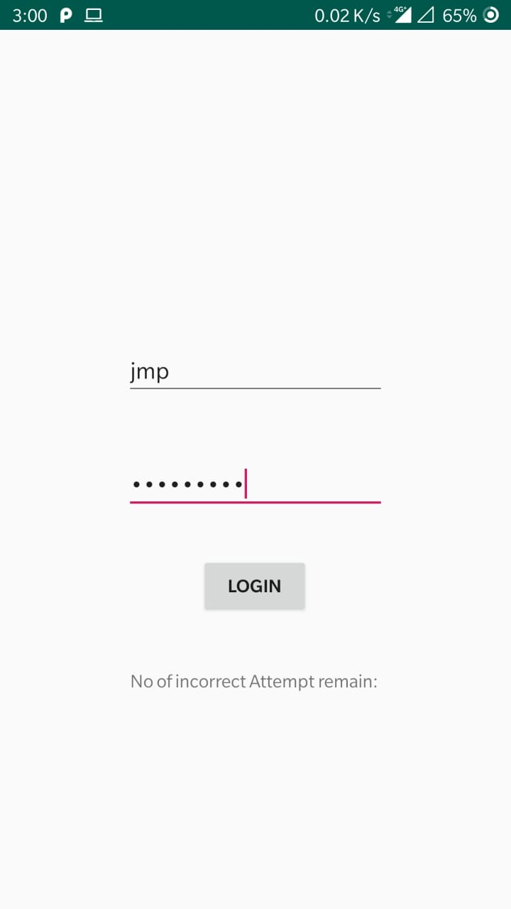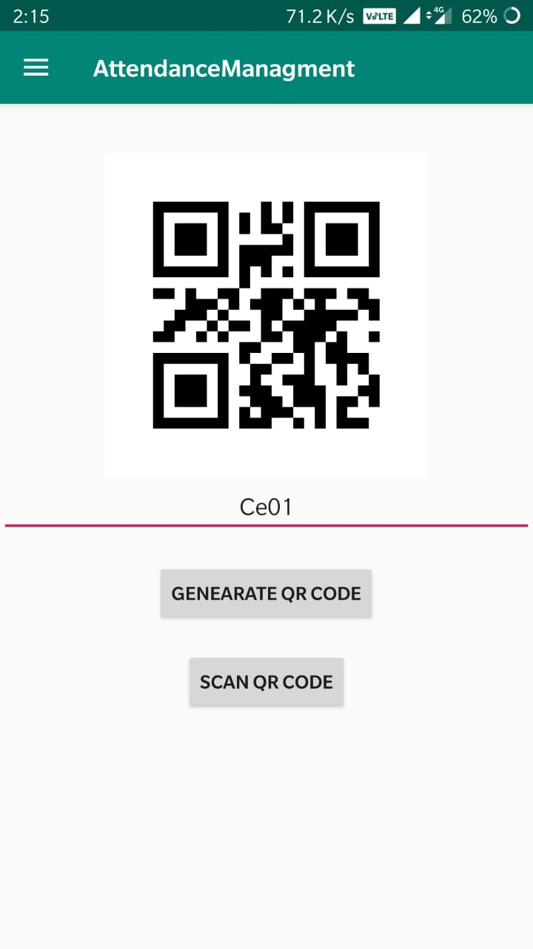

Admin Login Page

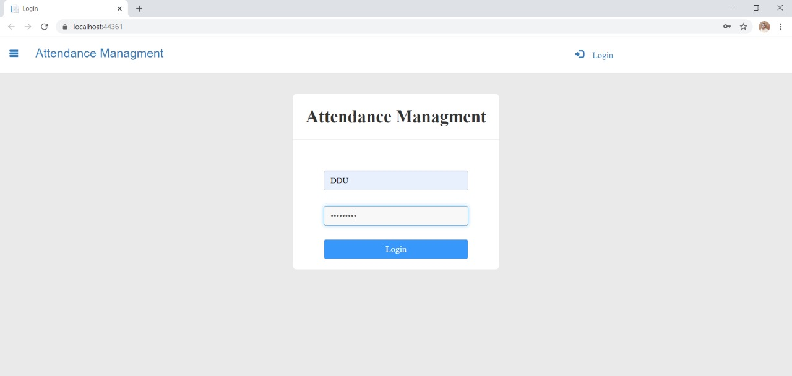

View Record

Register Student

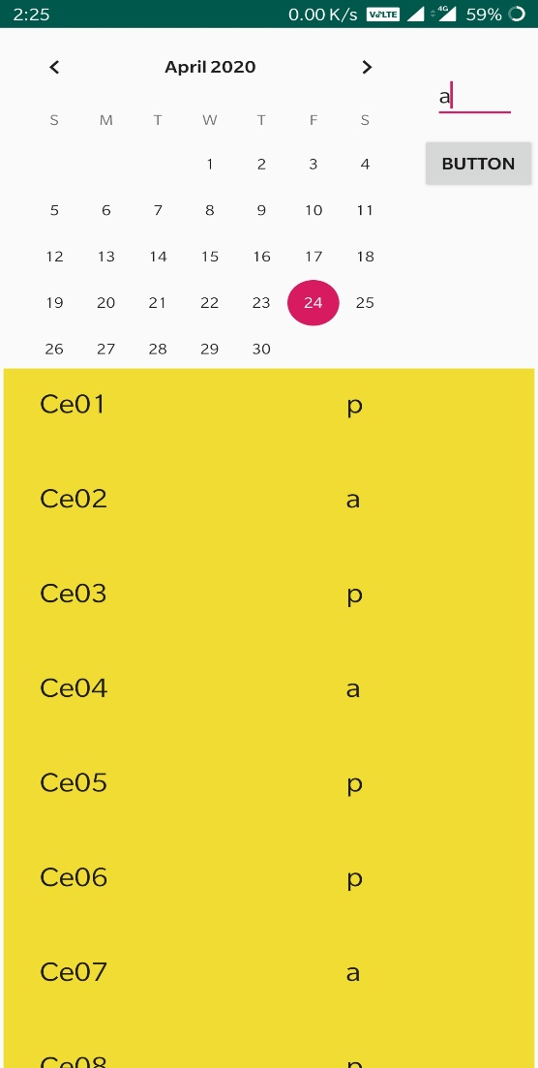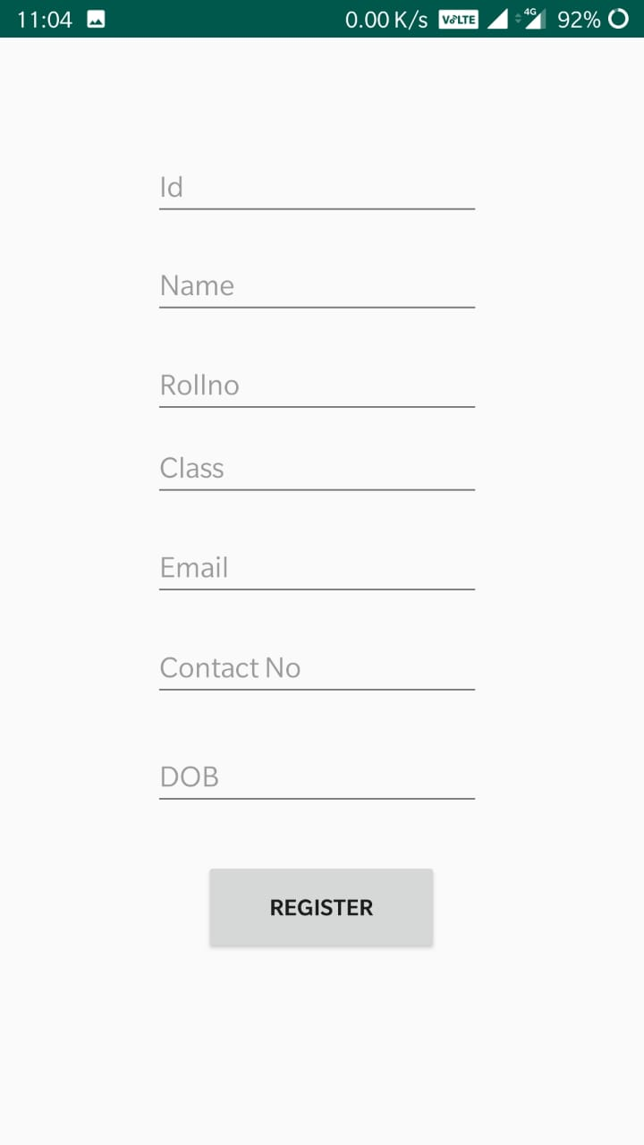

|  |  |
| --- | --- |
| How to take attendance | Notify parents |
|  |  |

Teacher List at Admin side

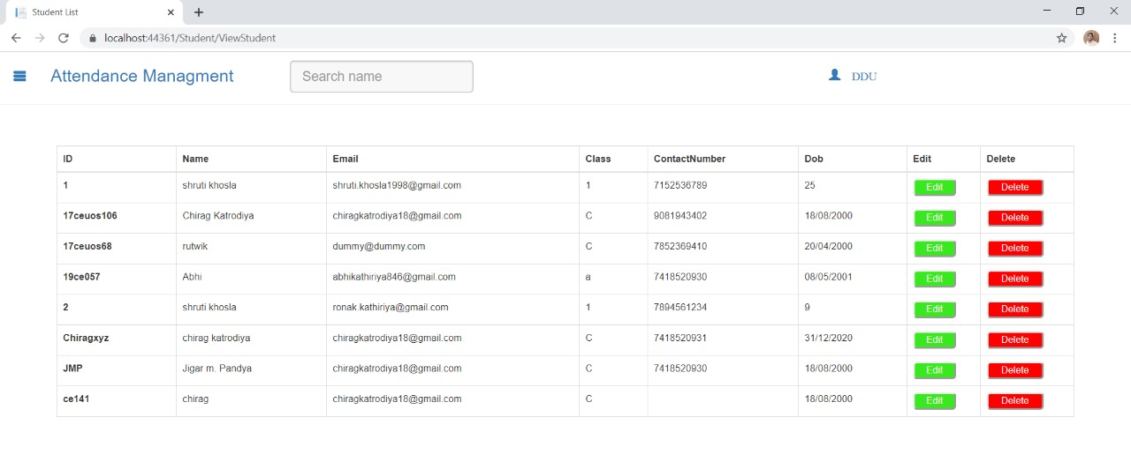

Student List (Generate ID card) at Admin side

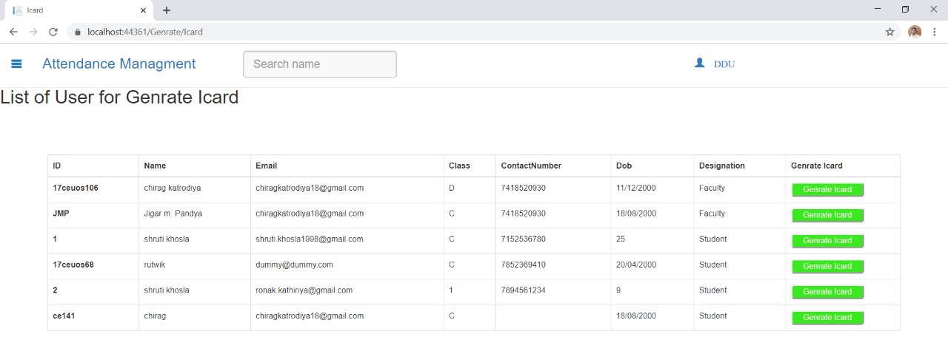

R

Ge

Generated Id card by Admin



r

# Conclusion:

Hence-forth in this project we have successfully implemented the Admin-side & Teacher-side functionality, Admin will add the teacher & teacher can register the students of their class. Admin can show all the students and generate Qr code from student’s ID no, and create ID card. This ID card will be scanned by teacher on working day and the attendance will be taken for that day. Record can be seen by teacher of any of any class. They can notify absent children’s parent also.

# Limitations:

1. This project is suitable at school level. If we think at college level, this project cannot able to take attendance at every lecture.
2. If students forget to take Id card along with them. Then teacher can generate Qr code from this application for that student.
3. Student will not able to interact directly with the system.

# Future Extension:

# To take over the limitations we planning this future extension in our system.

1. Creating a Student interface.
2. If any institute want our system, we can expand it for working in college (ex. Every lecture attendance should be taken).

# Bibliography

### References/resources used for developing project:

* <https://developer.android.com/reference/android/widget/CalendarView>
* <https://developer.android.com/studio>
* <https://developers.google.com/android/reference/com/google/firebase/firestore/DocumentSnapshot>
* <https://www.youtube.com/results?search_query=recyclerview+android+firebase>
* https://www.c-sharpcorner.com/article/crud-with-blazor-using-google-cloud-firestore

Online Database

* <https://console.firebase.google.com/u/1/project/attendancemanagment-1c187/database/firestore/data~2FInstitute~2FDDU~2FAttendance>